**Practical 9**

# SQL – Basic SELECT statement

## Objectives

At the end of this practical, you should be able to:

* Connect to **Oracle Database Server** using the interface (**SQLDeveloper**) provided by the vendor.
* Issue basic SELECT statements to query the **ORDER** database.

## Tasks

### A. Connecting to Oracle Database Server

You will need to do a one-time configuration of SQL Developer before using it. Follow the steps listed below:

1. Click on the icon **SQLDevelope**r on your desktop.



1. Right-click on the **Connections** icon and select **New Connection** (see below).

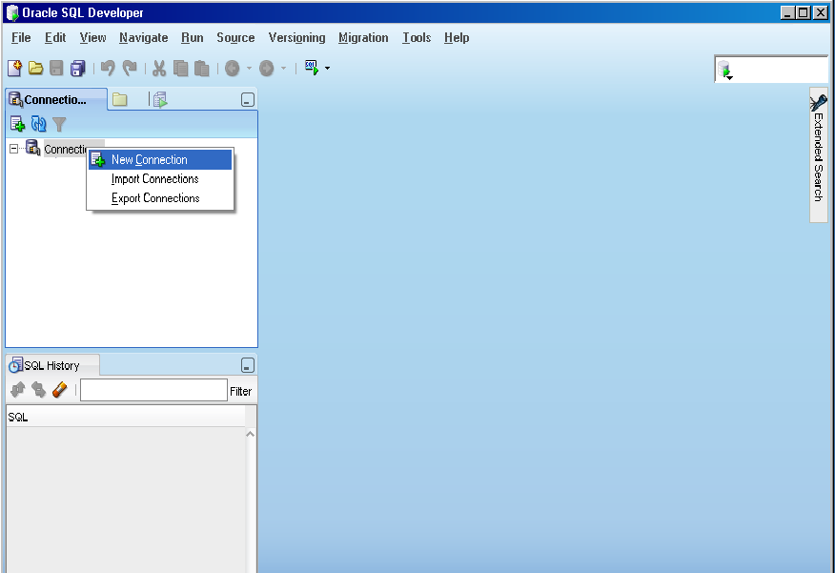

1. The following screen will be displayed. Enter the details as shown below and click **Connect**:

**password: studpass**

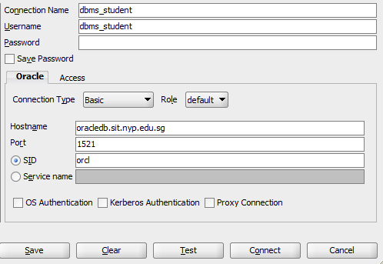

1. You are now connected to the database.
2. You can now input your SQL statements in the **SQLDeveloper** window (see below).

a) Enter your SQL statement in right panel on the screen.

b) Click on the “Execute Statement” icon (or Press the **F5** function key) to run a single selected SQL statement.



d) Check the lower half of the screen for the query result or any error messages.

Shows the history of your SQL statements.

Check the query result here.

Input your SQL statements in this window and click on the icon to run it.

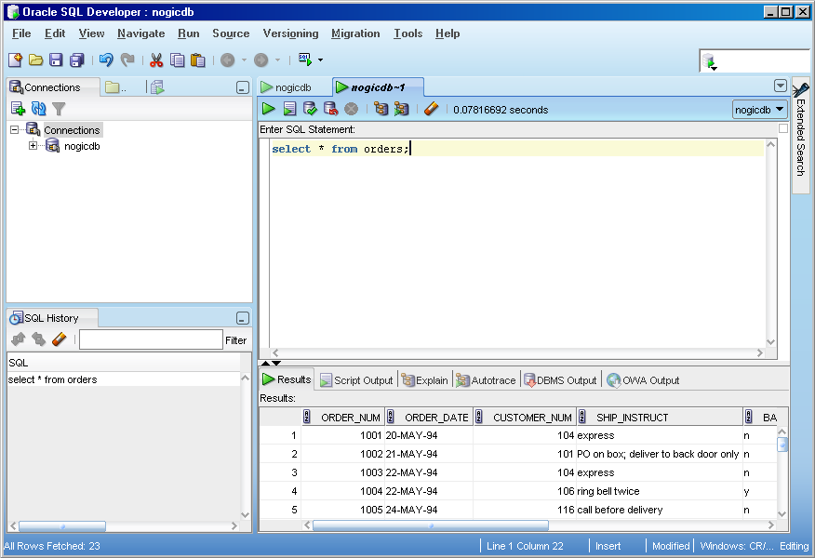

1. To save your SQL statements in a text file, select from the menu : **File** 🡆 **Save As** or click on the icon in the toolbar.



1. To exit from the system, select from the menu : **File** 🡆 **Exit**
2. Some useful **SQL*Plus** commands :

|  |  |
| --- | --- |
| **Commands** | **Remarks** |
| desc[ribe] *table_name* | To display the structure of a table. |
| -- s*ingle comment line* | -- comment line |
| /* … */ *multi-lines comment* | /* comment line1  comment line2  …  */ |

1. You are now ready to start practicing your SQL statements.

### B. Querying the ORDER database

The **ORDER** database schema is given in page 5. This database consists of 7 tables and each table is populated with some sample records.

Syntax for the basic SELECT statement :

**SELECT** [**DISTINCT**] *select list*

**FROM** *tablename*

**{**[**INNER JOIN** *tablename* **ON** *condition*]}

[**WHERE** *condition*]

[**ORDER BY** *column list* [**DESC**]]

Write the SQL statements for the following queries (the underlined words give you hints on which table(s) to retrieve the required information):

**SELECT … FROM … ORDER BY …**

1. (i) Retrieve the full details of all the Orders. (2 methods) (Ans : 23 rows selected)

(ii) Study the output. In what order are the rows sorted ? (In ascending order of .)

(iii) Amend your SQL so that the output rows are arranged in ascending order of the Customer Number.

1. (i) List the full name (i.e. fname and lname) and the full address (i.e. address1, address2, city, state_code and zipcode) of all the Customer. (Ans : 28 rows selected)

(ii) Study the output. What the values in the state_code ? (Ans : CA, ) Hint: you may write another SQL to help you to retrieve the distinct values in state_code.

(iii) Amend your SQL in part (i) so that the output rows are arranged in ascending order of the lname.

**Computed/derived column, round( ) function**

1. The company has just announced a 10% increase in shipping charges for shipping the Orders.

(i) List the Order Number, the existing shipping charge (i.e. ship_charge column) and the new shipping charge (derived from the existing shipping charge column) for all the Orders. Give the derived column a name (alias) called ‘new_ship_charge’. (23 rows selected)

(ii) Amend your SQL to round the new shipping charge to the nearest dollars, i.e. 0 decimal place.

**Concatenation, substr( ) function**

1. (i) List the customer’s full name (i.e. concatenate the first name and the last name to form one field) of all the Customer. (28 rows selected)

(ii) List the last 3 characters of the customer’s zip code. (Zip code is 5-characters.)

**WHERE condition clause**

1. (i) Amend your SQL in question 2 (i) to retrieve only those customer *living in state ‘AZ’*. (Ans : 2 rows selected)

(ii) Retrieve full details of those Orders which *have not been paid yet*, i.e. Paid Date has NULL value. (Ans : 6 rows selected)

(iii) Retrieve full details of those Products (from Product table) *supplied by supplier ‘HRO’*. (Ans : 12 rows selected)

(iv) List the product number, product description (from Product_desc table) of those products *related to ‘tennis’*, i.e. tennis racquet, tennis ball, etc. (Ans : 2 rows selected)

(v) List supplier code, supplier name (from Supplier table) of those suppliers whose *name start with letter ‘H’*. (Hint : use substr( ) function in WHERE clause) (Ans : 2 rows selected)

**Multiple Tables Queries (INNER JOIN .. ON)**

**For question 6 to 8, explore how you can add in an additional condition in the WHERE clause, to answer the questions prompted.**

1. One customer can place one or more orders. List the customer info (i.e. customer number, first name, last name) and his/her order info (i.e. order number, order date). (Ans : 23 rows selected)

Hint : Join Customer and Orders tables.

What are the orders placed by customer 104 (Anthony Higgins) ? (1001, , , )

1. One order can consists of one or more products. List the order info (i.e. order number, order date) and the products bought in the orders (list product number and quantity). (Ans : 67 rows selected)

Hint : Join Orders and Order_detail tables.

What are the products bought in order 1022 ? (309, , )

1. One product (e.g. tennis ball) can be supplied by many suppliers (refer records in Product table). List the product info (product number, product description) and its supplier’s info (supplier code, supplier name). (Ans : 74 rows selected)

Hint : Join Product to Product_desc, Supplier tables.

Who are the suppliers for ‘football’ ? (Hero, )

**OPTIONAL EXERCISE**

**For question 9 to 10, explore how you can add in an additional condition in the WHERE clause, to answer the questions prompted.**

**Multiple Tables Queries (SELF-JOIN)**

1. Some customers are referred by other customers. List the customer fullname (with alias as “Customer Name”) and the corresponding referral fullname (with alias as “Referral”) in ascending order of the customer fullname.

Hint : Join Customer to Customer tables (Self-join)

Which customers are referred by customer 102 (Carole Sadler)? (Jason Wallack, )

**Multiple Tables Queries (LEFT/RIGHT OUTER JOIN .. ON)**

1. The company marketing team wants to identify which states in the country they need to reach out in their upcoming marketing campaign. List all states, with any existing customers.

Which are the state names starting with ‘A’ where there are no customers yet?

(Alaska, , )

### ORDER database schema

|  |  |
| --- | --- |
| **Column Name** | **Data Type** |
| order_num | number(6) |
| item_num | number(3) |
| prod_num | number(3) |
| suppl_code | varchar2(3) |
| quantity | number(3) |
| total price | number(9,2) |

|  |  |
| --- | --- |
| **Column Name** | **Data Type** |
| customer_num | number(5) |
| fname | Varchar2(15) |
| lname | Varchar2(15) |
| company | Varchar2(20) |
| address1 | Varchar2(20) |
| address2 | Varchar2(20) |
| city | varchar2(15) |
| state_code | varchar2(2) |
| zipcode | varchar2(5) |
| phone | varchar2(18) |
| referred_by | number(5) |

**customer**

**orders**

**order_detail**

|  |  |
| --- | --- |
| **Column Name** | **Data Type** |
| order_num | number(6) |
| order_date | Date |
| customer_num | number(5) |
| ship_instruct | varchar2(40) |
| backlog | varchar2(1) |
| po_num | varchar2(10) |
| ship_date | date |
| ship_weight | number(9,2) |
| ship_charge | number(9,2) |
| paid_date | date |

**product_desc**

**product**

|  |  |
| --- | --- |
| **Column Name** | **Data Type** |
| prod_num | number(3) |
| suppl_code | varchar2(3) |
| unit_price | number(6,2) |
| remarks | varchar2(15) |

|  |  |
| --- | --- |
| **Column Name** | **Data Type** |
| prod_num | number(3) |
| prod_desc | varchar2(15) |

**state**

|  |  |
| --- | --- |
| **Column Name** | **Data Type** |
| state_code | varchar2(2) |
| state_name | varchar2(15) |

**supplier**

|  |  |
| --- | --- |
| **Column Name** | **Data Type** |
| suppl_code | varchar2(3) |
| suppl_name | varchar2(15) |
| lead_time_in_days | number(3) |

Foreign key references

|  |
| --- |
|  |

Primary keys